Presentation

My name is Jill Moth Poulsen and I’m living in Denmark. I’ve been a dressagerider until I was in my late teens but the I sold the last warmblood and bought two minis. In 2013 my first AMHA arrived and I’ve been pretty hocked since then. I love the size, exterior and spirit and for me the AMHA horse gives me all I want from the horse world. Time with horses, great experiences and the best friends anyone can have. I haven’t missed the riding horses for one second…
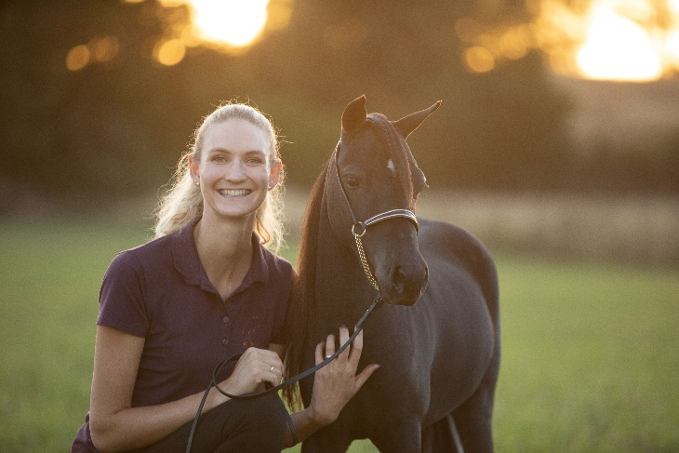
In 2014 I showed at an approved show for the first time and since then I’ve been attending approved shows in Sweden, Holland and Belgium. I currently own 5 AMHA’s and will breed one mare this year. Showing is my passion but since we bought our own farm I will make a foal now and then. I love the driving division and will always enjoy a nice moving horse but lately the halter horses have caught my eye and I have placed one filly in training for this season. I hope to learn a lot and have some fun showing in Europe. I would be honored to be the Danish director and help promote these lovely horses.
