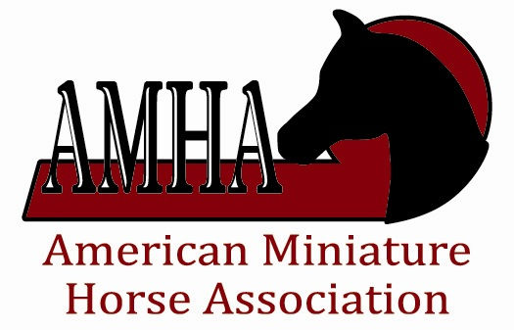
The Reece Family Youth Award

This award will be given in memory of Ronnie Reece and in honor of the Reece family. The recipient is selected by the youth committee, from nominations from the youths local clubs based on leadership, sportsmanship, enthusiasm, competitiveness and versatility and someone that other youth look up to as a role model.

Nominee Name: _____________________________________________________________________________
Address: _____________________________________________________________________________________

City: _______________________________ State: _______________________ Zip: _______________________

Reason you think they should be chosen for this honor:

Youth may be nominated for this award by an individual, group, or club. Please include the name of the person or group who is making the nomination. The deadline for Nominations is one month prior to the start of the World Show. The winner of this prestigious award will be announced at the World Show Youth Parade.

Please submit a nomination by mailing an entry form to:

AMHA – Attn: Reece Family Youth Award
5601 S. Interstate 35W
Alvarado, Texas 76009

Or email nominations with all the information to: val@amha.org

Subject: Reece Family Youth Award

